What is the term used in warehouse terminology for movement of goods from receiving location to a storage location.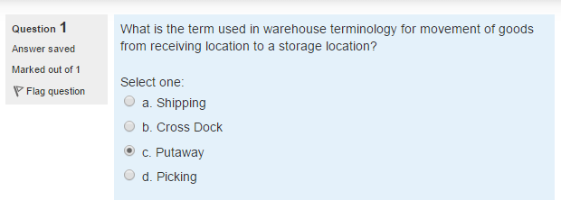

Which of the following are modes of transportation in transportation management?

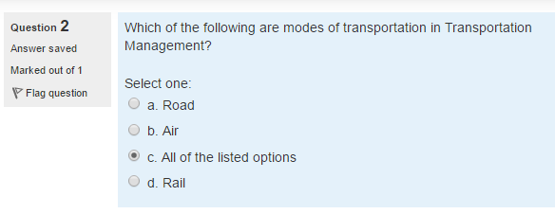

What are the Demand patterns?

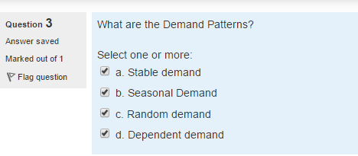

Which of these combinations yields the highest net profit before tax?

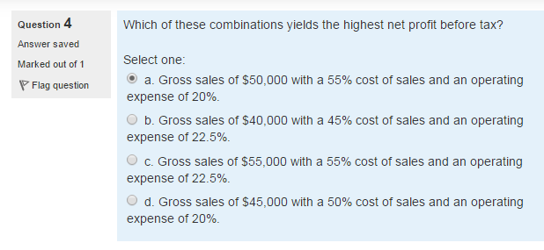

Company ABC generated $150 million of net profit in 2015. If the companys shareholders equity is $500 million then what is the return on equity value?

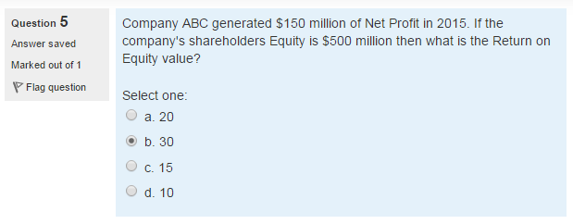

Inventory is commonly used to describe the goods and materials that a business holds for the ultimate purpose of resale. True or False?

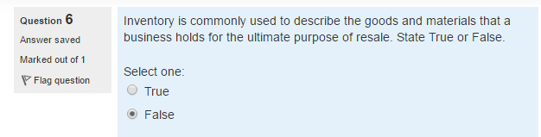

What are the major inbound operations in a warehouse?

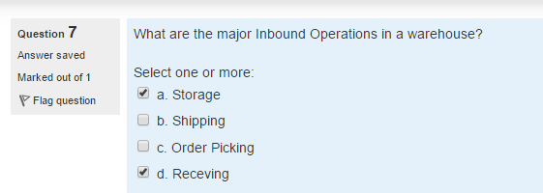

Given that the previous forecast of 65 turned out to be four units less than the actual demand. The next forecast is 66. What would be four units less than the actual demand? The next forecast is 66. What would be the value of alpha, if the simple exponential smoothing forecast is being used?

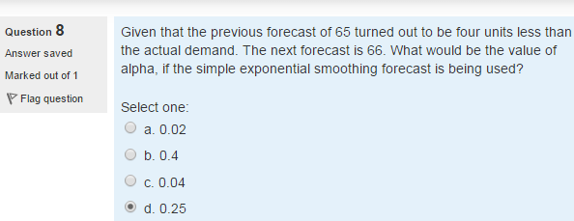

Carol King is evaluating the inventory performance of Johnston Systems. A recent annual report (all figures in millions) indicates assets of $16000, inventory of $1000 and cost of goods sold of $24000. What is the inventory turnover and what percent of assets are tied up in inventory?

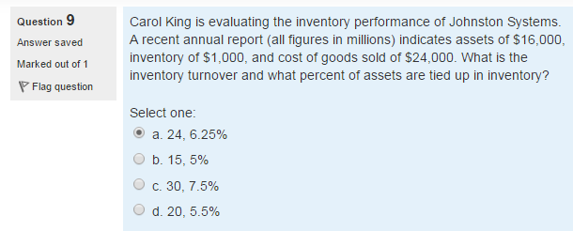

What are Ordering Costs?

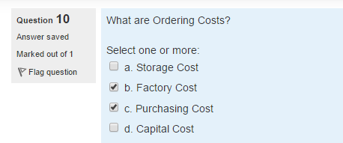

Can a transport order change request be processed if the goods are in the warehouse and yet to be in transit?

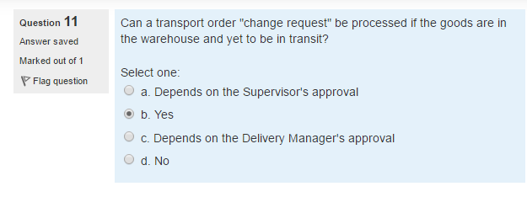

Identify the correct purchasing strategies from below?

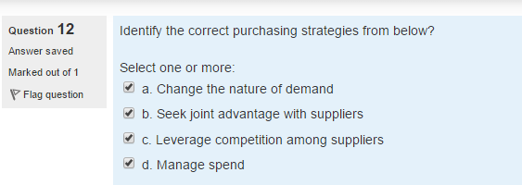

Which of the following included in the outbound process of WMS?

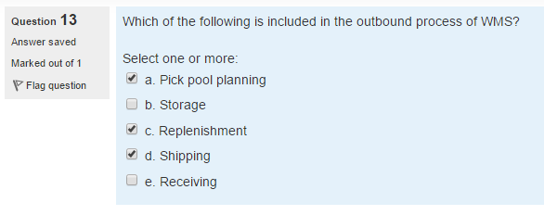

What is the supply chain management activity that involves purchasing of raw materials?

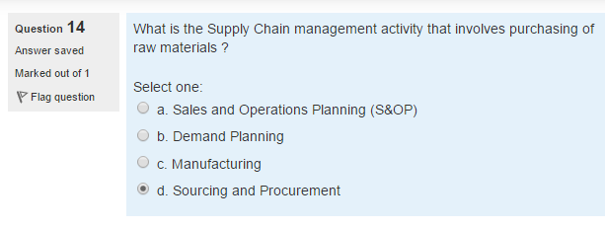

William Gus is an Executive Vice President at Sears and oversees the system. The retailer depends on to make 5000 home deliveries per day and moves 250000 truckloads of goods every year. With 30 large distribution

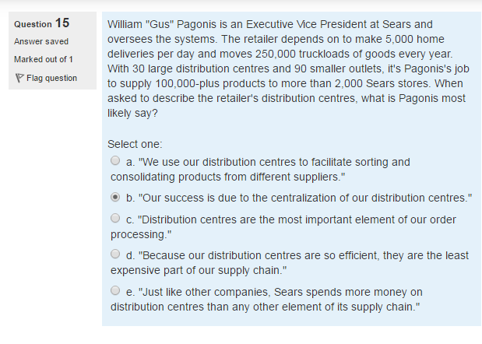

Cash Flow has become a critical issue in your

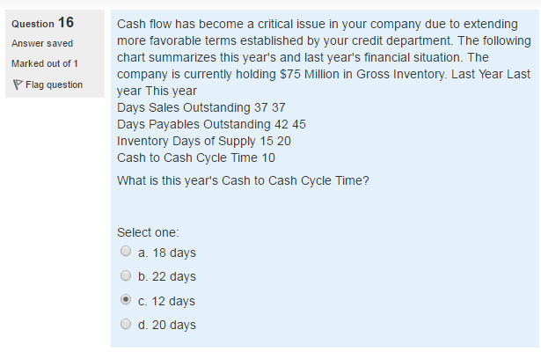

What is the position of customer in the supply chain network.

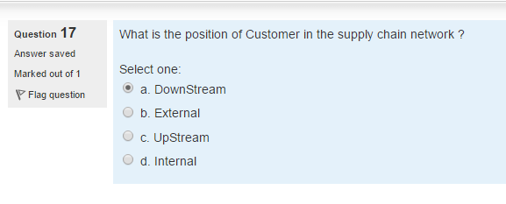

What are the points need to be considered while identifying a supplier.

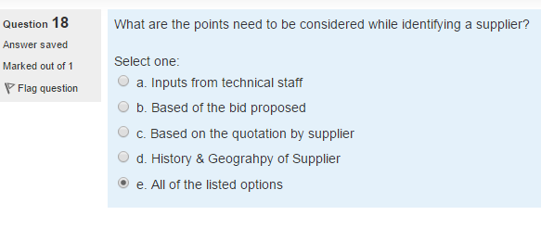

Company XYZ is one of the top automotive . 2012 $3 billion

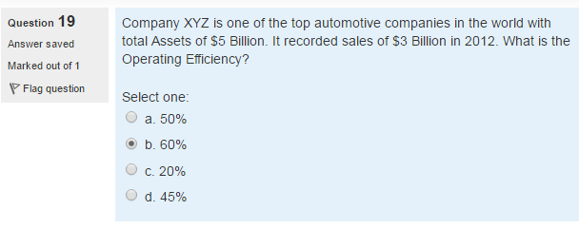

In order management if goods are in transits then transport order changes can be handled. True False.

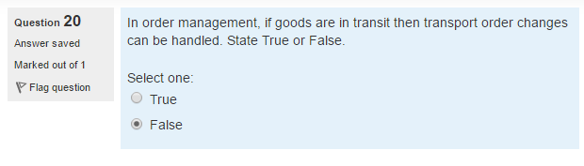

Manufactured goods in a supply chain network typically flows to

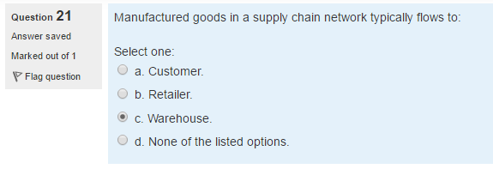

Konoha is one of the top automotive

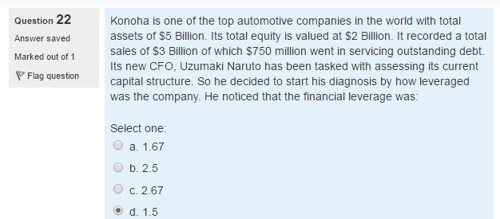

A company produces a finished product which uses nuts, bolts and fasteners in the assembly process.

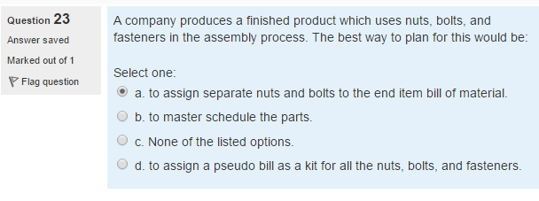

Which of the following is most accurate about revenue sharing in a supply chain with two firms, a retailer and a supplier.

**To assign pseudo bill as a kit for all the nuts, bolts and fasteners**

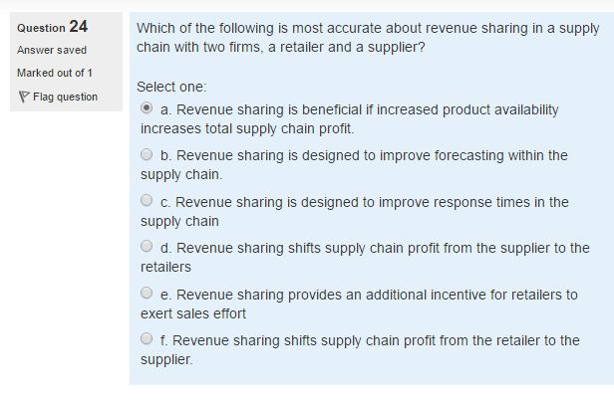

What are the types of supplier relation?

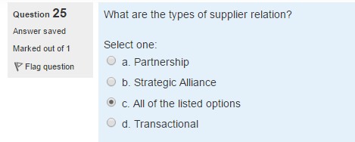

Purchasing is not an activity of acquiring goods or service to accomplish the goals of an organization. True or False

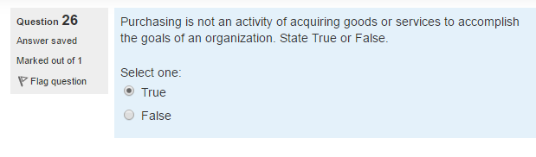

Which of the following is included in the inbound process of WMS?

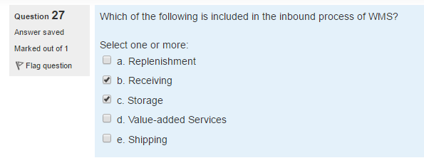

Which of the following is major challenge during putway?

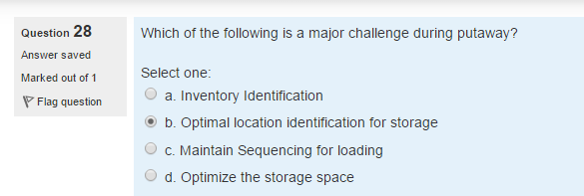

Select from below options which could be purchased

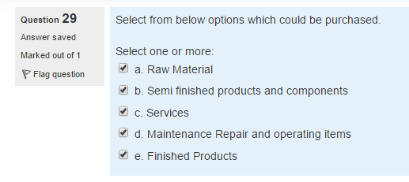

What is the immediate process followed once sale orders are entered in to ERP system.

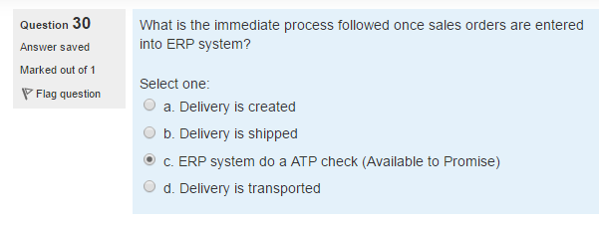

In make to stock requirements, customer orders are satisfied from.

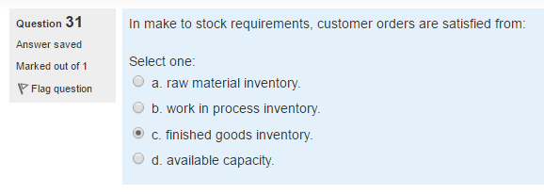

Annual Sales= $26 million, Average inventory= $2 million, annual cost of goods sold= $12 million. What is the value of inventory Turns?

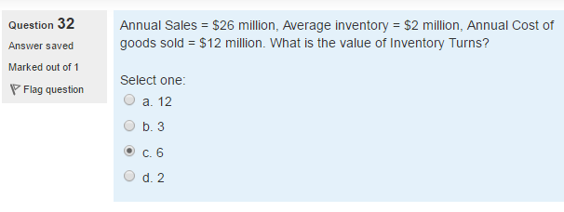

Stable demand retains in same general shape over time. True False

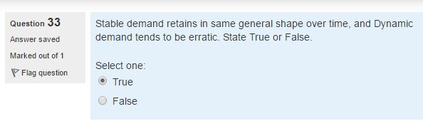

The determination of safety stock levels is based in a comparison of which

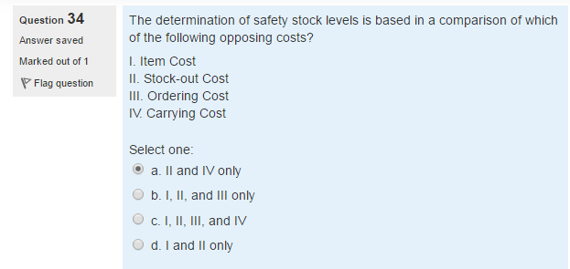

Konoha is one of the top automotive companies in the world with total assets of % Billion. $500 $750

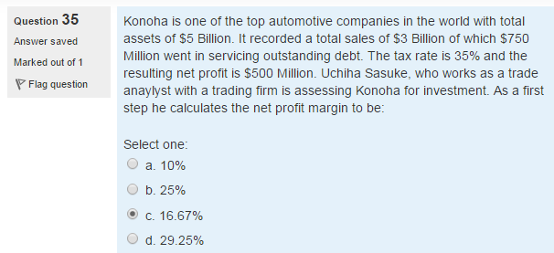

What are the features involved in value-added service in WMS?

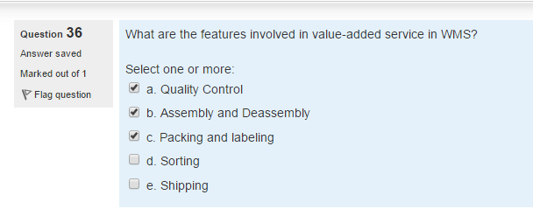

Which of the following are considered for resource management process in WMS?

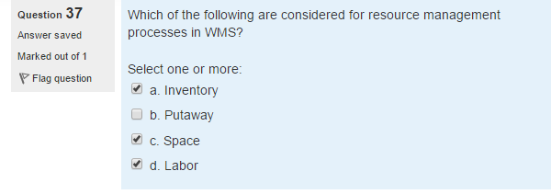

Which of the following options is False about a supply chain?

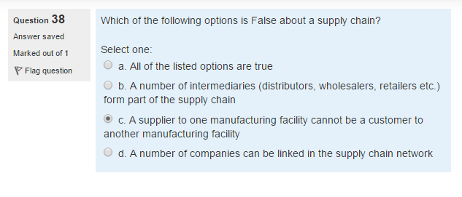What are the key objectives in verifying after receiving in the purchasing process?

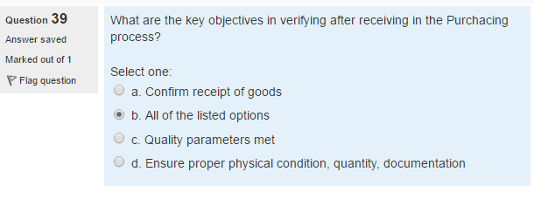Big Apple Appliance sells

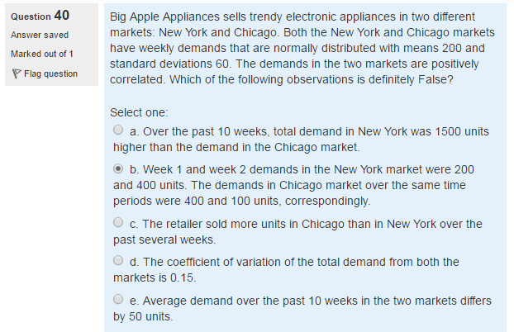

What is a Plastic Container

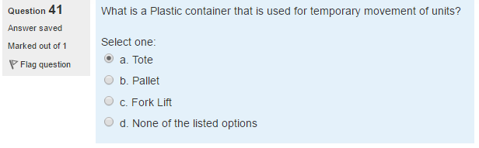

Who identifies the need for a product in the market.

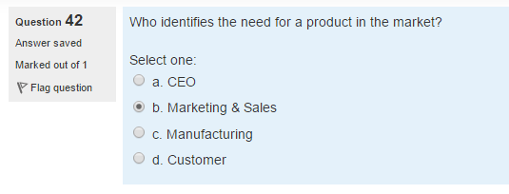

Which of the following statements defines purchase order?

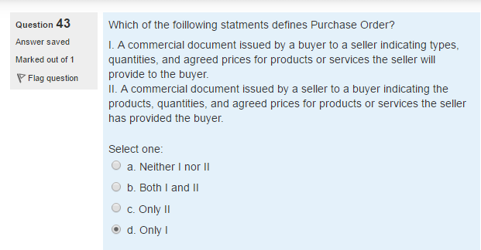

Industry studies have shown that on an average

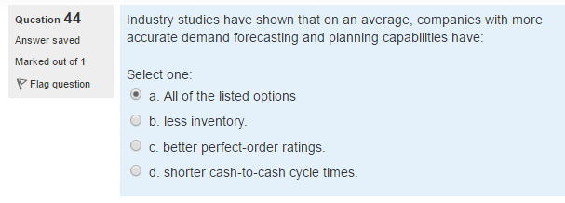

If sales of a company is 4700 million 950 4000

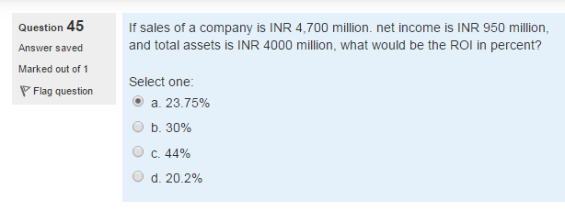

The Process of generating a statistical

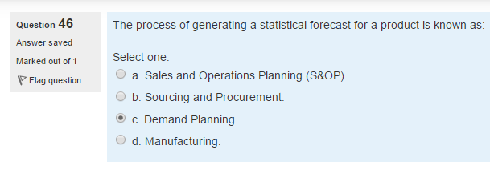

Dependent demand is not

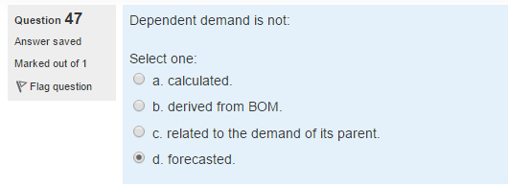

The inventory turns ration measures which of the following options

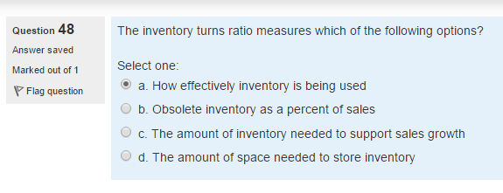

Which of the following are involved in seasonal forecast process.

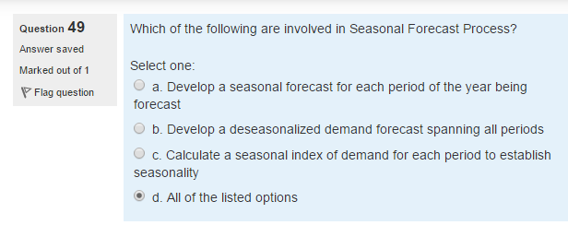

ATP is an acronym True False

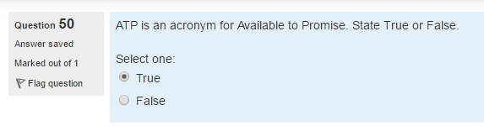

Delphi method of forecasting is an example of

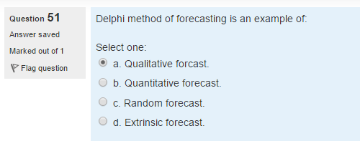

What are the major Outbound operation in a warehouse

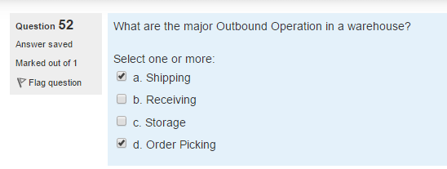

FTL and LTL terminology is associated with which of these in transport management?

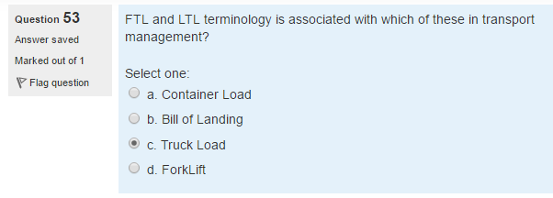

Which one of the following is not true about EOQ True

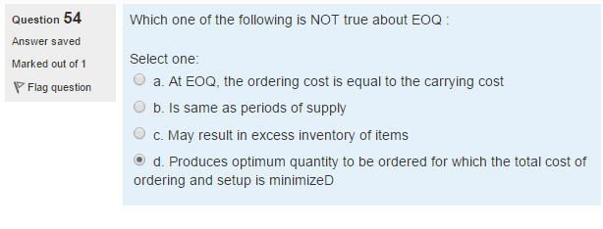

A work center consist of three machines 90%

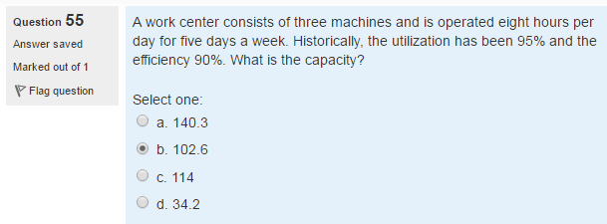

Grass Roots, Panel True False

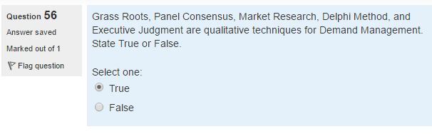

What are the cause of inventory Stockouts?

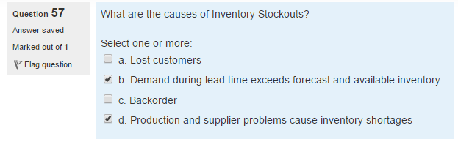

WIP inventory is associated with which process type.

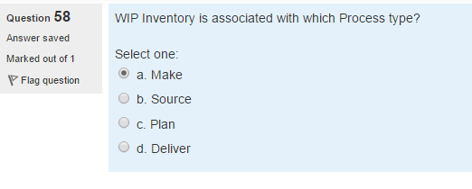

The Movement of carton from general storage location to the picking location for fulfilling a customer order is called. Replenishment

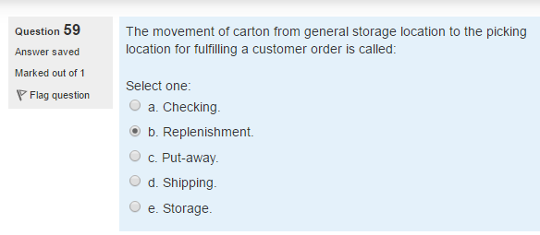

A work center has 4 machines that are 8 hours 5 days 128 hours

